To: District Employees
From: District Insurance Committee
Date: January 6, 2011
Re: NOTICE OF LIFE INSURANCE RATE CHANGE

In December, the District Insurance Committee was informed by the District’s life insurance carrier that rates were being increased as of February 1, 2011. After further negotiations to reduce the increase, the following rate changes were established:
Basic Life |  | Current  Group Rates | New Rates  2/1/2011
 |  | $1.00 | $1.20 | For $10,000 benefit  (employee pays 25%)
Optional Life  (Employee & Spouse) |  | Current  Group Rates | New Rates  2/1/2011
Age:
<29 |  | $ .04 | $ .06 | For $1,000 of benefit  (employee pays 100%)
30-34 |  | $ .05 | $ .07 | For $1,000 of benefit  (employee pays 100%)
35-39 |  | $ .05 | $ .07
40-44 |  | $ .08 | $ .11
45-49 |  | $ .08 | $ .11
50-54 |  | $ .12 | $ .17
55-59 |  | $ .31 | $ .43
60-64 |  | $ .43 | $ .60
65-69 |  | $ .70 | $ .98
70-74 |  | $1.40 | $1.96
75+ |  | $2.36 | $3.30

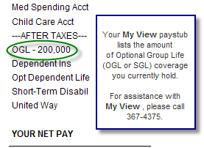
Example: If you are 53 and you have $100,000 of Optional Group Life, your current monthly Optional Life rate is $12 per month and your new rate (as of February 1) will be $17.

Basic Life Insurance is pre-taxed, and therefore is not eligible for a mid-year change. However, Optional Life (both employee and spouse) is not pre-taxed. Therefore, if you are interested in canceling or reducing your (and/or your spouse’s) level of coverage, please contact Michelle McConnell in Human Resources at 367-7662. If you want your change to be effective for your January paycheck, please contact Michelle no later than January 17.

